

QUIZ PRACTISING SYSTEM

Software Requirement Specification

Group Member:

Ngô Doãn Luân-HE151070

Đào Xuân Phương- HE150271

Lê Vĩnh Phú- HE153610

Nguyễn Xuân Hoàng- He150923

Nguyễn Tuấn Tú- HE150687

– Hanoi, May 2022 –

Record of Changes

Version | Date | A* | In charge | Change Description
 |  | M, D
V1.0 | 13/5 | Add | All of the | determine the topic
 |  |  | members
V1.1 | 14/5 | Add | Đào Xuân | 1.Product Vision.
 |  |  | Phương
 |  |  |  | 2. Product Context
V1.2 | 15/5 | Add | Ngô Doãn Luân | 3. Major Features.
V1.3 | 16/5 |  |  | 4. User Requirements.
 |  |  | Lê Vĩnh Phú | 4.1 Actors List
 |  | Add |  | 4.2 Use Cases.
V1.4 | 16/5 | Add | Nguyễn Xuân | 5. Assumptions & Dependencies.
 |  |  | Hoàng
 |  |  |  | 6. Limitations and Exclusions.
v1.5 | 16/5 | Add | Nguyễn Tuấn | 7. Business Rules.
 |  |  | Tú
*A - Added M - Modified D - Deleted

Table of Contents

I. Product Overview..

- Product Vision.

- Product Context

- Major Features.

- User Requirements.

- 1 Actors List

- 2 Use Cases.

- Assumptions & Dependencies.

- Limitations and Exclusions.

- Business Rules.

I. Overview

- Product Vision

The Quiz Practice system is a web application system that is a new system for online learning and knowledge training during the Covid-19 pandemic. This system is expected to help students, students can have tests on the level of knowledge of the subjects studied, thereby assessing their general knowledge of the subject. This project aims to develop a practice test support system for organisations/professionals who build and sell practice test services, assist users in finding registration and accessing online courses online to practise.

2.Product Context :

The connections between the PQS with the external entities are as described in the below diagram
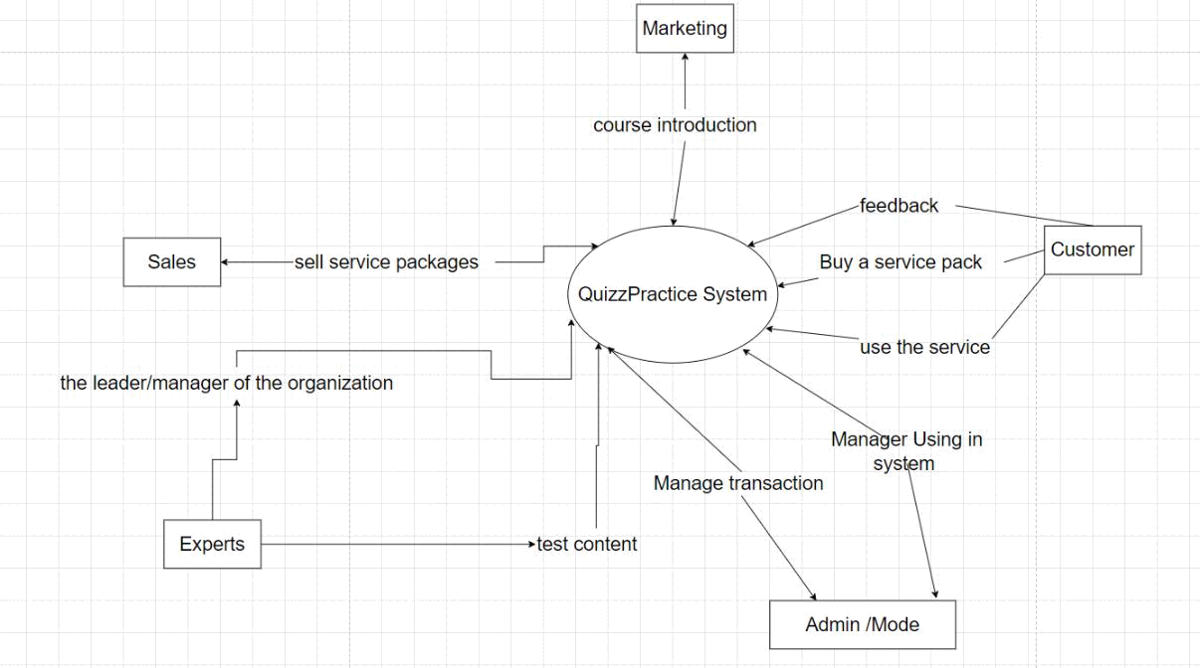

3.Major Features :

FE-01: Login to use access system , if user have account sign in and use and not user can sign in new account

FE-02: In the system , user can choose option in menu to study or choose the subject

FE-03: View and approve marketing blog

FE-04: Give the quiz practices of reputable experts

Fe-05 :Provide system access through internet or mobile phone
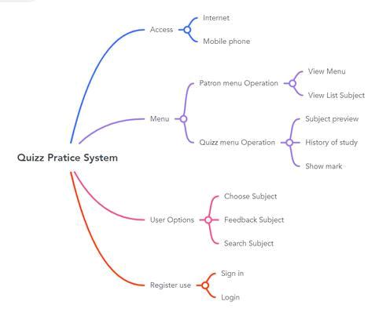

4. User Requirements

4.1 Actors List

# | Actor | Description
1 | Administrator | manage all activities of customer, Experts, Maketting. sale. Get
 |  | notified about all the above activities
2 | Customer/user | Non-logged in users are only allowed to take certain practice
 |  | quizzes . with customer can view the blog and full practice quiz
3 | Experts | create a course create a question they will receive notifications
 |  | when their courses go on sale

4

Maketting

Post marketing articles for products that are courses and practice quiz packages


5

Sale

provides information or services to sell practice quiz

4.2 Use Cases
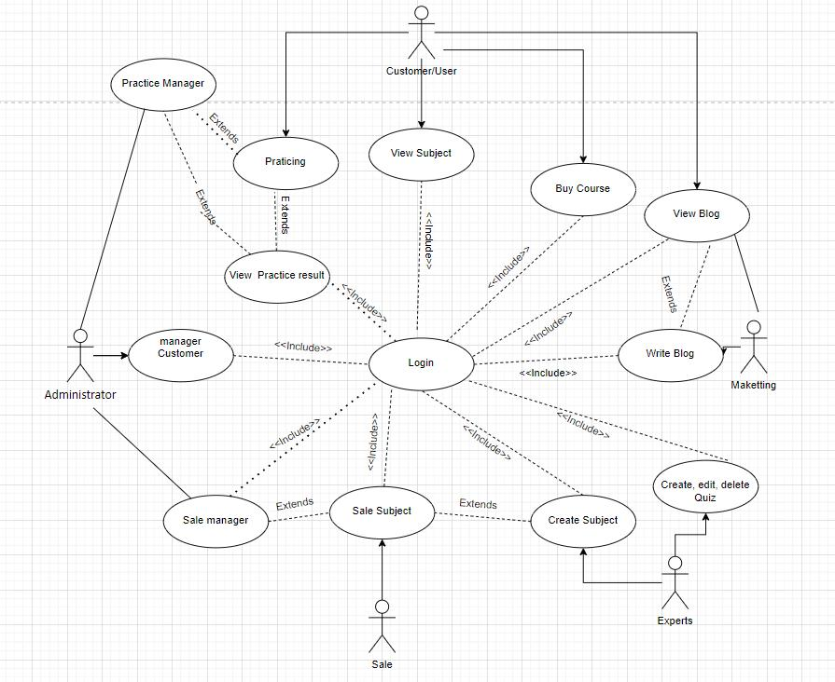

5.Assumptions & Dependencies

AS-1: Systems with appropriate user interfaces will be available to staff to handle large volumes of system registrations

AS-2: The staff on duty of the practice test system will always be available to respond to customer requests

DE-1:if experts want to add, edit and delete practice quiz, they have to do it under the management of administrator and depends on the feedback of user

6.Limitations and Exclusions

- Recharge function into the system to pay when customers want to register for a certain course.

- Save customer information, exams or assignments when losing connection to the system that is in the process of being executed.

7.Business Rules for Quiz Practices System

ID | Type of | Rule Definition | Static or Dynamic | Source
 | rules
01 | Facts | Always ensure the confidentiality for the | Static | Quiz Practice Policies
 |  | parties involved
02 | Facts | The system has a grading function and | Static | Quiz Practice
 |  | sends feedback right after the end |  | Manager
03 | Constraints | The update process must be completed | Dynamic | Quiz Practice
 |  | from 1am to 5am to limit the impact on |  | Manager
 |  | the user experience
04 | Constraints | The system operation process can not | Dynamic | Quiz Practice
 |  | accommodate a large number of visitors |  | Manager
 |  | at the same time
05 | Facts | Paid functions are paid with the same | Static | Quiz Practice Policies
 |  | payment method.
06 | Facts | Verify account , if use gmail , phone | Static | Quiz Practice Policies
 |  | number , username existing user can not
 |  | sign up the system.
07 | Facts | Order price is calculated as the sum of | Static | Quiz Practice
 |  | courses price user want to purchase |  | Manager
08 | Facts | Only one user uses one at the same time . | Static | Quiz Practice Policies

II. Use Case Specifications

1.

 | ID and Name: | UC-01 Buy a course
 | Created By: | Nguyen Tuan Tu |  |  |  | Date Created: | 5/30/22
 | Primary Actor: | Tu |  |  |  | Secondary | Quiz Practising System
 |  |  |  |  |  | Actors:
 | Description: | Tu accesses the Quiz Practising System from the Phone or PC, views the course ,
 |  | selects the course he wants to learn, places an order for the course and he can
 |  | buy a course with multiple payment methods.
 | Trigger: | Tu wants to buy a course.
 | Preconditions: | PRE-1. Tu is logged into Quiz Practising System
 |  | PRE-2. Tu has chosen a course that he wants to learn.
 | Postconditions: | POST-1. Tu must choose a payment method including(VISA,
 |  | Mastercard,Paypal,...)
 |  | POST-2. Quiz Practising System sends Tu an email message confirming order
 |  | details, price.


Normal Flow: 1.0 Order a Course

- Tu searches for a course on Quiz Practising System.

- The Quiz Practising System will show a list of courses that related the result he was looking for.

- Tu selects one course that he wants to learn.

- Quiz Practising System displays the description of that course and if he clicks the enroll button, Quiz Practising System will redirect him to the checkout page.

- Quiz Practising System displays prices of the course he has chosen and he needs to choose the payment method for the course.

- Quiz Practising System confirms acceptance of the order.

- Quiz Practising System sends Tu an email message confirming order details, price.

Exceptions: 1.0. Cancellation while preparing to complete payment:

1. The Quiz Practising System notifies Tu wants to cancel the order.

2 a. If Tu chooses to cancel the pending order, the Quiz Practising System cancels the pending order .

2b. Otherwise, Tu is required to pay and set the course.

Priority:

High

 | Frequency of | Approximately 1 million users. Peak usage load for this use case is between 7:00
 | Use: | A.M to 5.00 P.M. local time.
 | Business Rules: | BR-5, BR-6, BR-7, BR-8.
 | Other |  | 1. Tu shall be able to cancel the course ordering process at any time prior
 | Information: |  | to confirming it.
 |  |  | 2. Tu shall be able to view all courses he ordered.
 | Assumptions: | Assuming users who buy multiple courses will get a 5 percent discount every 3
 |  | courses.
 | 2.
 | ID and Name: |  | UC-02 View Subject
 | Created By: |  | Đào Xuân Phương | Date Created: | 30\05\2022
 | Primary Actor: |  | Customers | Secondary Actors: | QUIZ PRACTISING SYSTEM
 | Description: |  | Customers, after accessing QUIZ PRACTICE SYSTEM from the intranet of
 |  |  | organisations or individuals. The system will suggest you the trending topics
 |  |  | or the most searched courses in the field a certain period of time or related
 |  |  | topics that you have been interested in. In addition, you can actively find
 |  |  | yourself suitable courses by searching directly on the system. From there
 |  |  | you can view and search for the topics you need.


Trigger: Many individuals or organisations indicated that they would like to see topics from which to make further decisions.

Preconditions: PRE-1. individuals or organisations that have logged in to QUIZ PRACTICE SYSTEM.

Postconditions: POST-1.individuals or organisations that have searched for or used the system's courses

POST-2.approval or referral from a 3rd party

Normal Flow: 2.0 View Subject

- The following customer performs the login process to

QUIZ PRACTICE SYSTEM

- -QUIZ PRACTICE SYSTEM will appear the most viewed or searched trending suggestions in a certain time slot (1 day or 1 week )

- _Customers can review the courses they have been studying in the history section

- -Customers who want to search for new courses can search through the search bar on the system

- -users can refer new members to their courses

None
Alternative Flows:

Exceptions: | 1.Free courses are constantly being suggested to individuals or
 | organisations
 | 2.If the customer does not want to see the recommendations of a certain
 | topic, it can be deleted and temporarily hidden
 | 3.I'm not logged in, but I'm busy, I can still see the suggestions, but I can't
 | go to school or practice

 | Priority: | High
 | Frequency of Use: | continuously make trending suggestions that are aggregated within 1 week
 |  | so that users can soon access a good and useful course
 | Business Rules: |  | BR-1, BR-2, BR-3, BR-4
 | Other Information: | 1. | Users can cancel the topics they have done or do not want to be
 |  |  | interested in at any time
 |  | 2. | Users can view all the topics they have been interested in in the
 |  |  | form of a list
 |  | 3. | The content of the topics will be continuously updated as diverse
 |  |  | as possible
 | Assumptions: | Assuming customers want to see quizz or hot topics that are of most interest
 |  | today, they can click on the top trending item (source: data has been
 |  | updated continuously for the past 1 week).

3.


ID and Name:

UC-03 Sale Subject

Created By: Ngo Doan Luan

Date Created: 30/05/2022

Primary Actor: Luan

Secondary Actors: Practice quiz system


Description: The user will access the system, and the home page will display the courses and their uses. Besides, it will make the price of the course that user can refer to the introductory quality price of the product and also get more information about discounts or promotions of courses to help users. have more options and consider them.

Trigger: users say they want to see the system's price information and promotion updates

Preconditions: PRE-1. User is logged into System.

PRE-2. Users click on course information and find out product prices .

Postconditions: Post-1. The system confirms the "Accepted" course purchase request.

Post-2. Check the information in the customer request to choose a payment method.

Post- 3. Check account information and process transactions, unlock the course when the transaction is completed

Normal Flow: 1.0 Sale Subject

- User selects course display item.

- The system displays the menu of subjects sorted by content and price.

- User selects one or more subjects. (see 1.1)

- User indicates course request is complete. (see 1.2)

- System displays the subjects in the menu and sorted by customer search.

- User confirms payment or changes course selection.

- The system displays the customer's transaction processing time and payment method, adding information about the successful purchase of the course (including where to store it and when to use it).

- The customer confirms the terms and processes the transaction.

- The customer specifies the payment method.

- The confirmation system accepts the order.

- The system sends the customer an email confirming the order details, price and instructions for use and storage..

Alternative Flows: 1.1 Order multiple identical subjects

- The user requests a specific number of identical subjects.

- Display the message that the course has been requested from the customer and is waiting for the next steps.

1.2 Order multiple subject

- User asks to order another subject .

- Return to step 1 of normal flow.

Exceptions: 1.0.E1 Requested date is today and current time after today's order closing time

- The system notifies the user that it is too late to place an order for today. 2 a. If the User cancels the meal order, the system terminates the use case.

2b. Otherwise, if the system asks for another date, the system will restart the use case.

1.0.E2 Cancellation while preparing to complete payment:

1. The system notifies the user of payment cancellation confirmation.

2 a. If the user chooses to cancel the pending order, the system cancels the pending order.

2b. Otherwise, the user is required to pay and set the course.

1.1.E1 Failed subject detection system:

- The system notifies the user that the course the user has ordered has a problem and the system needs to fix the problem.

2 a. If the customer agrees to return, then start over from the beginning of the process.

2b. Otherwise, the system displays a message and returns to the menu.

Priority: High

Frequency of Use: Approximately 300 users, average of one usage per day. Peak usage load for this use case is between 9:00 A.M. and 10:00 A.M. local time.
 | Business Rules: |  | BR-1, BR-2, BR-3, BR-4, BR-11, BR-12, BR-33
 | Other Information: | 1. User can cancel any course pass process before the payment is
 |  | received.
 |  | 2. | User can review all the courses he has booked and the price of the
 |  | purchased course.
 |  | 3. | The default date is the date the system updates the user storage
 |  | drive and adds new courses.
 | Assumptions: | Assuming users who buy multiple courses will get a 5 percent discount
 |  | every 3 courses.
 | 4.
 | ID and Name: | UC-04 quiz practicing
 | Created By: | Le Vinh Phu |  | Date Created: | 30/05/2022
 | Primary Actor: | Phu |  | Secondary Actors: | Quiz Practice System
 | Description: | A customer select Practice Quiz feature by selecting the desired subject
 |  | and lesson, select the time and number of questions. Complete the
 |  | Practice by clicking the Submit button. User can see the number of points
 |  | achieved, questions answered incorrectly, quizzes completed
 | Trigger: | A customer indicates that he wants to practice quizz


Preconditions: PRE-1. Customer is logged into PQS.

PRE-2. Customer bought a subject containing the quiz that his wanted to practice

Postconditions: POST-1. Quiz is stored in PQS with a status of “Accepted”.

POST-2. show incorrect answer and correct answer

Normal Flow: 1.0 Normal practice

- customer asks to view History of list finish quiz

- QPS displays list of list quiz detail (mark, time, status...)

- customer selects one of quiz to retake it

- customer indicates that practice complete. (see 1.2)

- QPS displays finished menu quiz, mark and rate, time to finish

- Patron either confirms to retake (continue normal flow) or requests to select either quiz(return to step 2).

- customer selects a delivery time and specifies the delivery location.

- customer specifies payment method.

- PQS confirms acceptance of the order.

Alternative Flows: 1.1 discontinuity practice

- customer encountered an interruption during practice

- System are break and return to step 4

Exceptions: 1.0. option to practice quiz not yet active or not to buy

- PQS informs customer that it’s not free and request to login and buy the subject

2a. if customer accept and login then PQS request enroll to subject by buy this subject

2b. Else break to home page
 | Priority: | High
 | Frequency of Use: | Approximately 300 users, average of 5 usage per day. Peak usage load for
 |  | this use case is between 9:00 A.M. and 10:00 A.M. local time.
 | Business Rules: | BR-1, BR-2, BR-3, BR-4, BR-11, BR-12, BR-33
 | Other Information: | 1. customer shall be able to cancel the meal ordering process at any
 |  | time prior to confirming it.
 |  | 2. User shall be able to view all quiz he finish within the previous ten
 |  | day and repeat one of those quiz as the new quiz practice
 | Assumptions: | Assume that 25 percent of user will recycle retake quiz to finish with mark
 |  | >9

 | 5.
 | ID and Name: | UC-05 View Blog
 | Created By: | Nguyen Xuan Hoang |  | Date | 5/30/22
 |  |  |  | Created:
 | Primary Actor: | Customer |  | Secondary | Quiz Practising System
 |  |  |  | Actors:
 | Description: | This is a place where customers can exchange information, reviews, comments
 |  | and interact easily and is a good way to improve customer satisfaction. Through
 |  | blogs, QUIZ PRACTICE SYSTEM are constantly updating customers' information.
 |  | The more people who visit the blog, the more exposure and trust the system is.


From there blog to help us reach potential consumers and attract their attention.

Trigger: Many individuals or organisations want to see reviews of comments and interactions in order to make decisions

Preconditions: PRE-1. individuals or organisations that have logged in to QUIZ PRACTICE SYSTEM.

Postconditions: POST-1.individuals or organisations that have searched for or used the system's courses

POST-2.Reviewed from a 3rd party

Normal Flow: 1.0 Order a Course

- The following customer performs the login process to QUIZ PRACTICE SYSTEM

- -QUIZ PRACTICE SYSTEM suggesting trends in most viewed or searched courses in a day or week

- -Customers can review the reviews and comments on the course

- -Users can refer new members to their courses

Exceptions: | 1.0. Cancellation while preparing to complete payment:
 | 1.Free courses with the highest rating and best interaction are continuously
 | suggested to clients
 | 2.If the customer doesn't want to see reviews and engagements, it may be
 | temporarily hidden
 | 3.Not logged in can still view reviews.

Priority: | High
Frequency of | continuously offering high-review courses that have been synthesised within 1
Use: | week so that users can better understand the course and help them to have
 | useful and quality courses.
Business Rules: | BR-1, BR-2, BR-3, BR-4.
Other | 1. | User can cancel his / her rating posted
Information:
 | 2. | Users can view all reviews on topics that interest them
 | 3. | Interactive and review posts are constantly being updated

Assumptions:

Suppose customers want to see the course with the most reviews, they can click the Vote item to see which course has the most favourite star Vote.


III.Functional Requirements

1

a . Screen Flow :
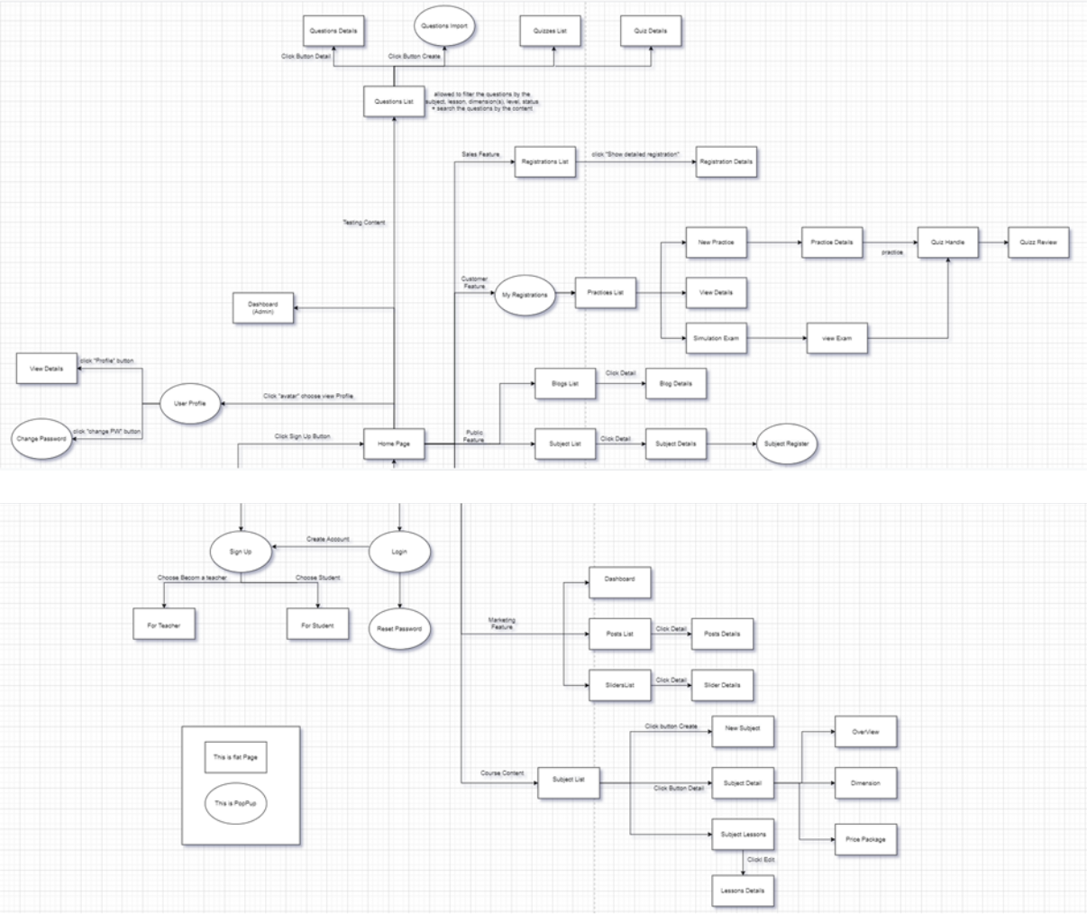

Admin :

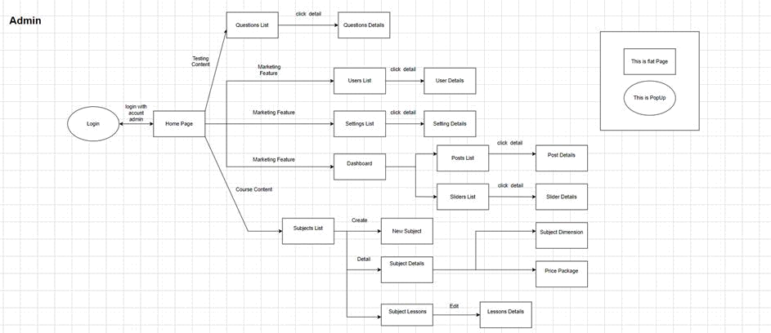

1.2 Screen Descriptions

# | Feature | Screen | Description
1 |  |  | Login Screen for users who have registered an
 | Common Feature | User Login | account before.
2 | Common Feature | User Register | Screen for new members who want to register.
3 |  |  | The user has an account and forgot it and
 | Common Feature | Reset Password | wants to recover a new password.
4 |  |  | authorise user into the system functions based
 | Common Feature | User Authorization | on his/her role
5 |  |  | View the user's personal page including all
 | Common Feature | User Profile | personal information.
6 |  |  | To help user change current password if they
 | Common Feature | Change Password | have account
7 |  |  | Is the homepage of the website, orienting
 |  |  | users, introducing the website and directing
 | Public Feature | Home Page | users to the main functions.

8 | Public Feature | Blogs List | list of shared blog posts about courses
9 | Public Feature | Blog Details | detail of the shared post
10 | Public Feature | Subject List | List of active subjects for users to refer to
11 | Public Feature | Subject Details | details of the selected subject
12 |  |  | allow the user to register to access a subject
 | Public Feature | Subject Register | with a specific price package
13 |  |  | This page is for the customer to view his/her
 | Customer Feature | My Registrations | submitted course registrations
14 |  |  | This page allows users to see a list of practice
 |  |  | tests they have taken. You can take the new
 |  |  | test directly or take the simulated test of the
 | Customer Feature | Practices List | web
15 |  |  | This page allows users to enter new practice
 |  |  | information to practice so that they can enter
 |  |  | the topic the desired number of sentences,
 | Customer Feature | Practice Details | where is the question range
16 |  |  | This page allows the user to view the existing
 |  |  | exams of the subject that s/he has the access
 | Customer Feature | Simulation Exam | to.
17 |  |  | Is to display the interface of the questions so
 |  |  | that the user answering can answer any page if
 |  |  | answering the question will be bold and can be
 |  |  | backward, next, first and last sentence and
 | Customer Feature | Quiz Handle | have a notice when submitting the test.
18 |  |  | This screen allows the user to review the
 |  |  | details of the test they have just taken. They
 |  |  | can view any sentence and show the
 |  |  | correctness of the question and can also show
 | Customer Feature | Quiz Review | the number of points the user has achieved.

19 |  |  | This is for the Admin, Sale or Marketing to see
 |  |  | and lookup for the relevant
 |  |  | management statistics in the system, with the
 |  |  | relevant links to the related screens.
 | Marketing
 | Feature | Dashboard
20 | Marketing |  | list, filter, search, show, hide, view, add new or
 | Feature | Posts List | edit existing post
21 | Marketing
 | Feature | Post Details | view & edit the details of a specific post
22 | Marketing |  | list, filter, search, show, hide, view, add new or
 | Feature | Sliders List | edit existing slider(s)
23 | Marketing
 | Feature | Slider Details | view & edit the details of a specific slider
24 |  |  | This screen allows the admin and expert to see
 |  |  | the existing course list. The admin can see all
 |  |  | the courses while the expert can only see his
 | Course Content | Subjects List | assigned courses
25 |  |  | This screen allows the admin to add new
 |  |  | course and assign the expert (owner) for
 | Course Content | New Subject | further course content preparation
26 |  |  | This page allows the admin and the assigned
 |  |  | expert to access and prepare the subject
 |  |  | information, including the course general
 |  |  | information, the dimension, and price package.
 |  |  | Only the admin can change the status to
 |  |  | Published or Unpublished + add/edit the price
 | Course Content | Subject Details | packages
27 |  |  | This page allows the admin/expert to input or
 |  |  | edit subject dimension information, including
 |  |  | the following detailed information: type, name,
 | Course Content | Subject Dimension | description

28 |  |  | This page allows the admin to input or edit
 |  |  | subject dimension information, including the
 |  |  | following detailed information: name, access
 |  |  | duration (in months), status (read-only), list
 |  |  | price, sale price, description. The expert can
 | Course Content | Price Package | only view the information.
29 |  |  | This page shows the list of lessons for a
 |  |  | selected package. On this page, the
 |  |  | admin/expert is allowed to activate/deactivate,
 |  |  | or call the Lesson Details for adding new or
 |  |  | editing existing lessons. The screen layout is as
 | Course Content | Subject Lessons | below
30 |  |  | This page allows the admin/expert to input/edit
 |  |  | the lesson information, with below screen
 | Course Content | Lesson Details | layout
31 |  |  | The existing questions list for a specific
 |  |  | subject/course are shown here (paginated). On
 |  |  | this screen, the admin/expert is allowed to
 |  |  | filter the questions by the subject, lesson,
 |  |  | dimension(s), level, status + search the
 |  |  | questions by the content. The page also allows
 |  |  | the user to import the question (redirect
 |  |  | him/her to the Questions Import pop-up
 | Testing Content | Questions List | screen.
32 |  |  | This page allows the admin/expert to input or
 |  |  | edit questions information, including following
 |  |  | information: subject, dimension(s), lesson,
 |  |  | status, content, media (image, audio, video –
 |  |  | with preview option), answer options (with the
 |  |  | key marked + ability to add, edit, delete), and
 | Testing Content | Questions Details | explanation

33 |  |  | This page allows the admin/expert to input or
 |  |  | edit questions information, including following
 |  |  | information: subject, dimension(s), lesson,
 |  |  | status, content, media (image, audio, video –
 |  |  | with preview option), answer options (with the
 |  |  | key marked + ability to add, edit, delete), and
 | Testing Content | Questions Import | explanation
34 |  |  | The existing quizzes are shown in this page
 |  |  | pagination: - The user can filter the list by
 |  |  | subject, quiz types + search quizzes by the
 |  |  | name
 |  |  | - Each quiz includes following information: id,
 |  |  | name, subject, level, # question, duration, pass
 |  |  | rate, and the quiz type.
 |  |  | From this page, the user has the option to call
 |  |  | to the Quiz Details page for adding new or
 |  |  | editing existing quizzes + delete the quiz.
 |  |  | Please note that the quiz can be edited only
 | Testing Content | Quizzes List | when there is not any test taken yet
35 |  |  | This page allows the user to input or edit quiz
 | Testing Content | Quiz Details | information

36 |  |  | Show the list of users' registrations
 |  |  | - Each registration includes below information:
 |  |  | id, email, registration time, subject, package,
 |  |  | total cost, status, valid from, valid to, last
 |  |  | updated by;
 |  |  | - The user can filter the list by subject
 |  |  | (searchable), registration time (from, to), status
 |  |  | + can
 |  |  | search by the email
 |  |  | - The list can be sorted by id, email, registration
 |  |  | time, subject, package, total cost, status,
 |  |  | valid from, valid to
 |  |  | - From the list, the user can choose to add new
 |  |  | or edit an existing registration via the
 | Sales Feature | Registrations List | Registration Details screen
37 |  |  | Show detailed registration information (subject,
 |  |  | package with list price/sale price, full name,
 |  |  | gender, email, mobile), registration time, sale,
 |  |  | status, valid from, valid to, notes) from that for
 |  |  | the user to add new or change the status of a
 |  |  | registration with relevant notes (if a
 |  |  | registration is created by the user, then s/he
 |  |  | can edit other registration information). On
 |  |  | changing a registration status to Paid, if the
 |  |  | user with relevant registered email does not
 |  |  | exist, the system would create one and send
 |  |  | back to the user the login information (link,
 |  |  | email, pass) along with the other notification
 | Sales Feature | Registration Details | notes
38 |  |  | list, filter, search, show, hide, view, add new or
 | Admin Feature | Users List | edit existing user(s)
39 | Admin Feature | User Details | view & edit the details of a specific user

40 |  |  | list, filter, search, show, hide, view, add new or
 | Admin Feature | Settings List | edit existing system setting(s)
41 |  |  | view & edit the details of a specific system
 | Admin Feature | Setting Details | setting

1.3User Authorization

reen | Guest | Customer | arketing | Sale | Expert | Admin
er Login | X
er Register | X
set Password |  | X | X | X | X
er Profile |  | X | X | X | X
ange Password |  | X | X | X | X | X
me | X | X | X | X | X | X
ogs List |  |  |  |  |  | X
og Details |  |  |  |  |  | X
bjects List |  |  |  |  |  | X
bject Details |  |  |  |  |  | X
bject Register |  | X
Registrations |  | X
actices List |  | X

actice Details |  | X
mulation Exams |  | X
iz Handle |  | X
iz Review |  | X
shboard |  |  | X | X |  | X
st Details |  |  | X
ders List |  |  | X
der Details |  |  | X
bjects List |  |  |  |  |  | X
w Subject |  |  |  |  |  | X
bject Details |  |  |  |  |  | X
bject Dimension |  |  |  |  |  | X
ce Package |  |  |  |  |  | X
bject Lessons |  |  |  |  |  | X
sson Details |  |  |  |  |  | X
estions List |  |  |  |  | X | X
estion Details |  |  |  |  | X | X
estion Import |  |  |  |  | X | X

izzes List |  |  |  |  | X | X
iz Details |  |  |  |  | X | X
gistrations List |  |  |  | X
gistration Details |  |  |  | X
ers List |  |  |  |  |  | X
er Details |  |  |  |  |  | X
ttings List |  |  |  |  |  | X
tting Details |  |  |  |  |  | X

In which:

- Guest: unregistered users

- Customer: they are registered users who are actual customers or potential customers

- Marketing: the marketing members of the organisation

- Sale: the sale members of the organisation

- Expert: access & prepare the course/test contents as assigned by admin

- Admin: the organisation leader/manager, acts as the system administrator

1.4

# | Feature | System Function | Description
1 | Usability | Design simple | Design easy to use and view information.
2 | Security | Security with a | The system will stop working for 10 minutes if the
 |  | password | user enters the wrong password 5 times in a row.
 |  |  | When user forgot password

1.5 Entity Relationship Diagram
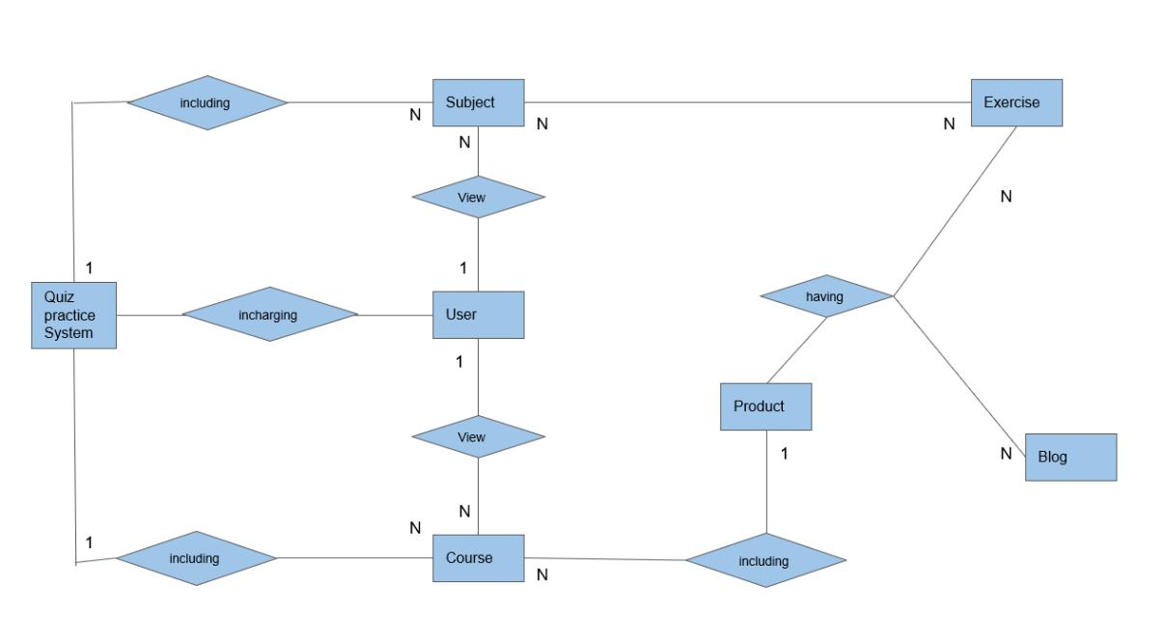

2.

2.1. User Login
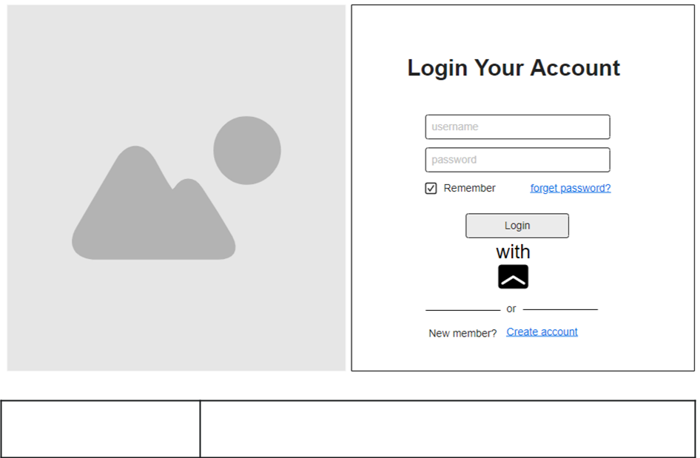

Action

User,Admin

Function trigger | Trang login được mở ra khi người dùng hoặc admin muốn đăng nhập vào
 | hệ thống có thể qua 1 liên kết cụ thể hoặc click vào button login
Function description | Trang này có thể cho người dùng , admin có thể đăng nhập vào hệ thống
 | ,có thể tạo tài khoản , forget Password
Function Details | login: có thể nhập tài khoản , mật khẩu sẵn có hoặc có thể đăng nhập
 | bằng gmail của người dùng
 | forget password: sử dụng để đưa người dùng vào giao diện forget
 | password để người dùng có thể lấy lại được mật khẩu
 | create Account: cho phép người dùng tạo 1 tài khoản mới

2.2 View Subject

*Subject list
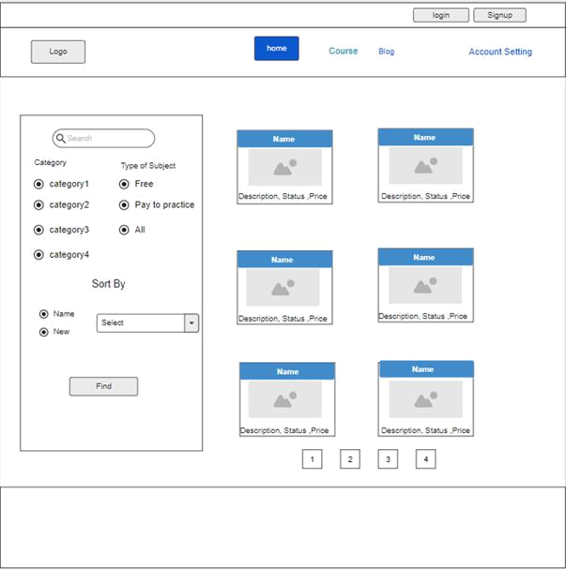

Action | User
Function trigger | Subject List được mở khi truy cập web và nhấp vào nút Subject List
 | trên thanh công cụ
Function description | Trang chủ của trang web, định hướng người dùng, giới thiệu và nhìn
 | được list các Subject

Function Details

Home: chuyển luồng về giao diện home


All Course: hiển thị tất cả các course trong web

Blog list : chuyển luồng đến giao diện hiện list các blog

login: để chuyển luồng đến giao diện login

sign up: chuyển luồng đến giao diện sign up

Search: được chọn các category và type của Subject và giao diện sẽ hiển thị list các blog có liên quan đến category đã chọn và có thể sort theo tên

Subject: trang web sẽ chuyển luồng về giao diện detail của các Subject

các button khác : mục đích phân sang, mở các giao diện phụ

*Subject Register

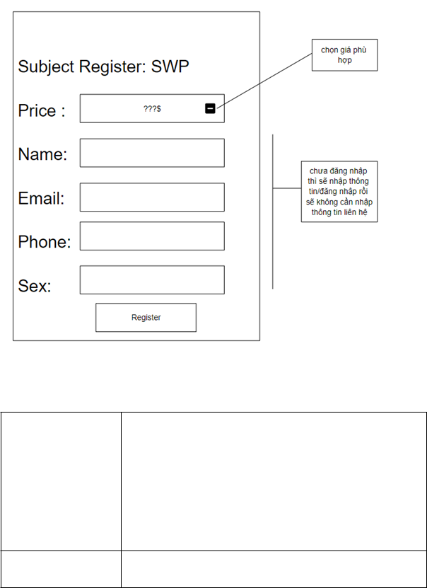

Action | User
Function trigger | Subject Register được mở khi người dùng click vào button enrol vào
 | khóa học
Function description | Trang chủ của trang web, Điền thông tin của người dùng để chọn
 | mua gói subject

Function Details

register: để xác nhận đăng ký mua dịch vụ

2.3 Payment :
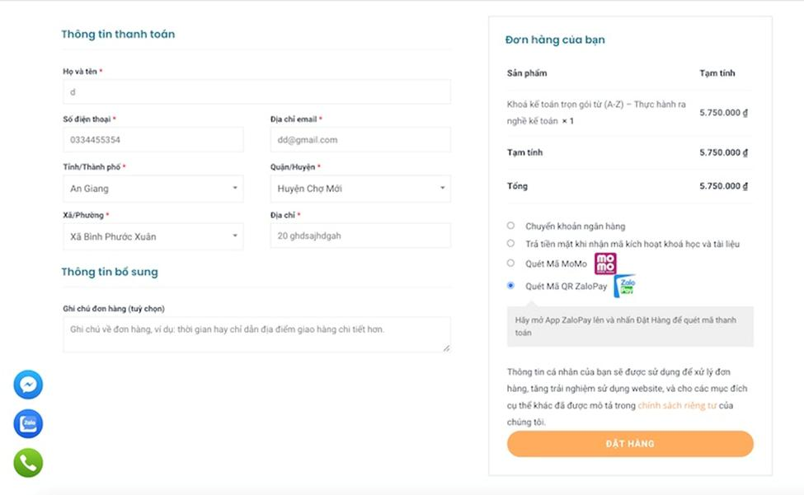
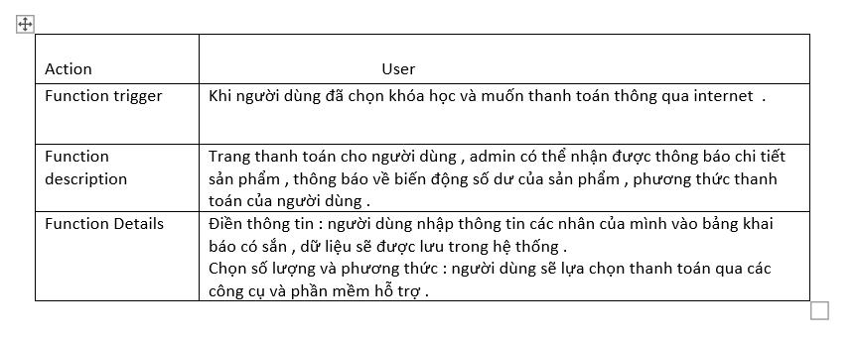
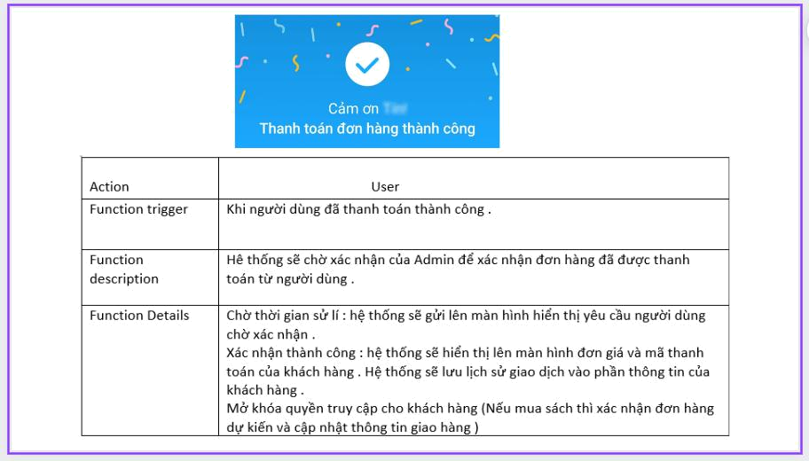

2.4 User Manager

2.4.1 User List
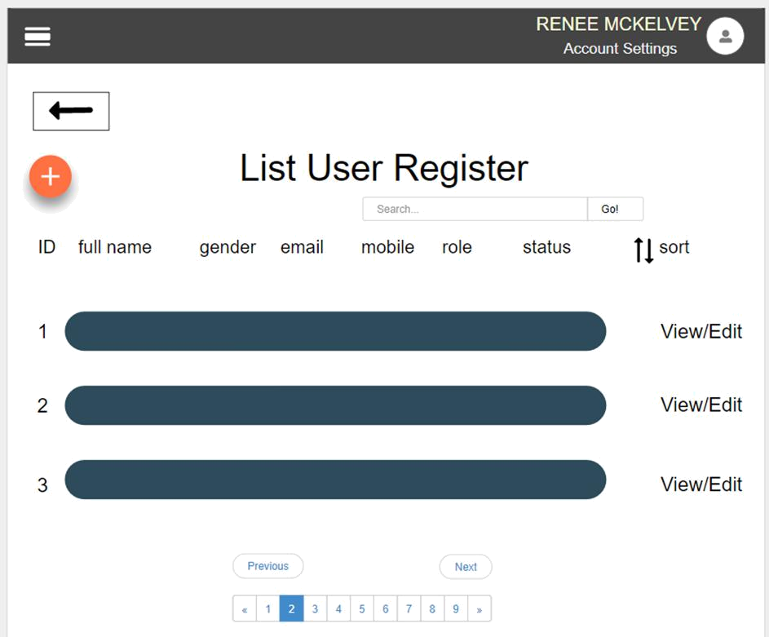

Action | Admin
Function trigger | User List được mở khi truy cập button User List trong trang Home
 | của Admin
Function description | Trang chủ của trang web, hiện thông tin Người dung đã đăng ký
Function Details | Account Settings: chỉnh sửa các thông tin về tài khoản
 | view : xem chi tiết thông tin của người đã đăng ký
 | Edit: Chỉnh sửa thông tin người đã đăng ký
 | các button khác : mục đích phân sang, mở các giao diện phụ

2.4.2 User Details
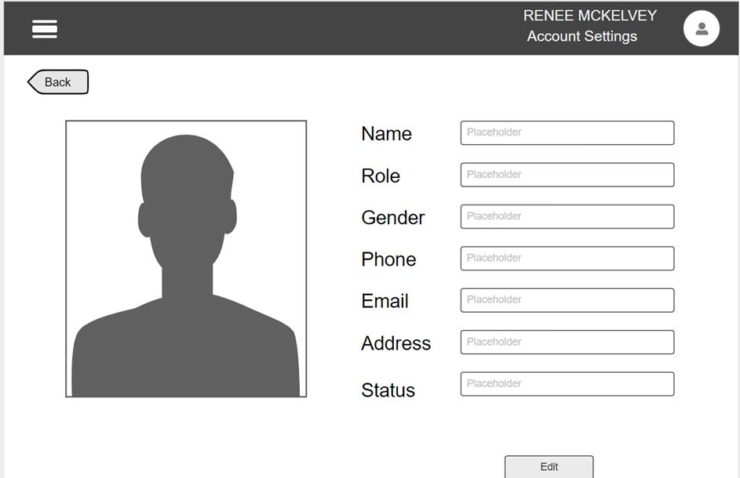

Action | Admin
Function trigger | User Detail được mở khi truy cập button Edit trong trang User List
 | của Admin
Function description | Trang chủ của trang web, hiện thông tin Người dung đã đăng ký và
 | được phép chỉnh sửa thông tin
Function Details | Account Settings: chỉnh sửa các thông tin về tài khoản
 | Back: trở lại giao diện User List của Admin
 | Edit: để thay đổi thông tin mình muốn sửa đổi

2.5 Home Page

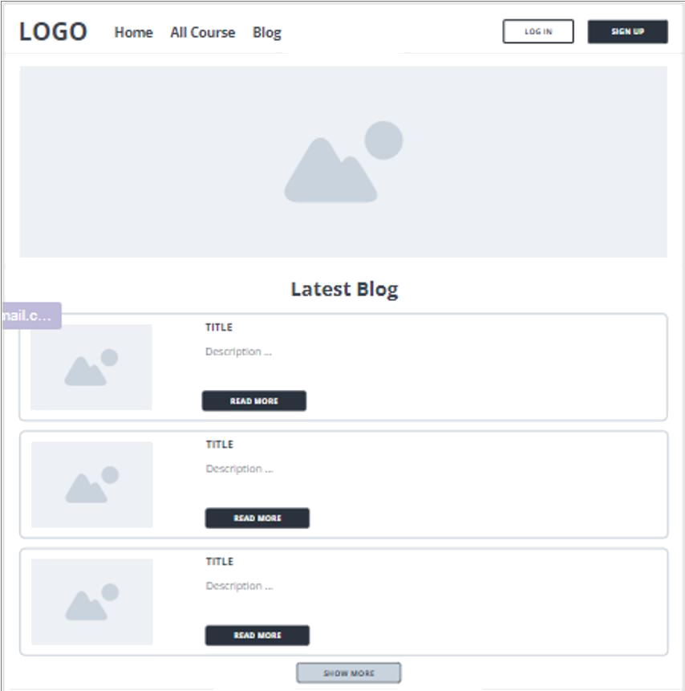
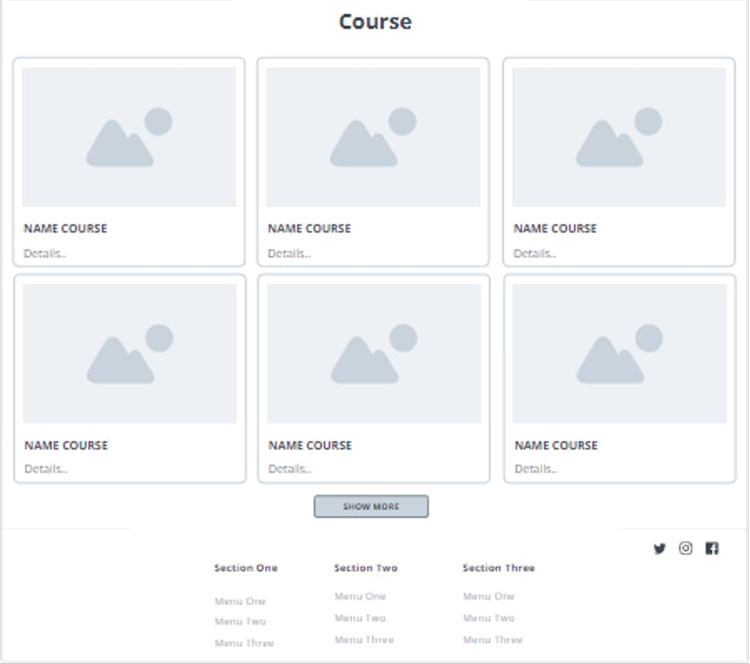

Action | User
Function trigger | Trang chủ của trang web, được mở khi truy cập web hoặc nhấp vào
 | nút trang chủ trên thanh tiêu đề khi đang ở trên một trang khác của
 | web
Function description | Trang chủ của trang web, định hướng người dùng, giới thiệu trang
 | web và hướng người dùng đến các chức năng chính.

Function Details

Home: chuyển luồng về giao diện home


All Course: hiển thị tất cả các course trong web

Blog list: chuyển luồng đến giao diện hiện list các blog

Login: để chuyển luồng đến giao diện login

Sign up: chuyển luồng đến giao diện sign up

Course: chuyển luồng đến giao diện hiện thông tin chi tiết của các couse

